Rotameter Equations and Derivations

Rotameter is mounted vertically. The bottom of the tube is narrow and gets wider as the top is reached. The flow originates from the bottom and moves the rotameter’s float up to the position in which the weight of the float balances the force exerted by the flow. If the flow remains lower than that of the speed of sound, then the incompressible Bernoulli’s equation can be applied as a balance on the rotameter system.
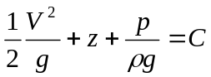
In this equation:
g = gravitational acceleration
V = velocity of the fluid
z = height above an arbitrary origin
C = constant along any streamline in the flow but varies from streamline
to streamline, a streamline is defined as a path in a steady flow field along which a given fluid particle travels

First, set equation equal to zero because all forces are balanced on the rotameter when the float is stationary, followed by simplifications:
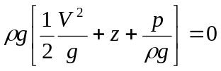

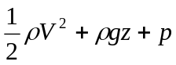

Then equate for points at bottom (a) and top (b) of the float:
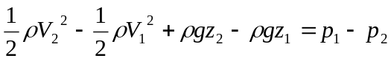
Which simplifies to:
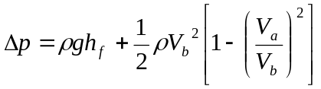
Where the subscript f is defines properties of the float, in this case h_{f} is the height of the float.

The volumetric flow rate is the same at the top and the bottom of the float, therefore:
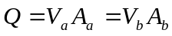
Where Q is the volumetric flow, V is the volumetric flow, and A is the area

Solving for 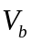 to get:
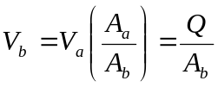
Substituting this value of simplified Bernoulli’s equation yields:
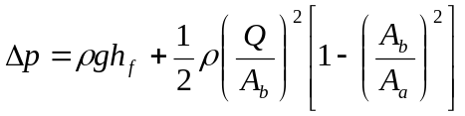
Solving for Q:
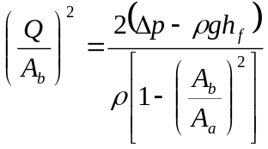
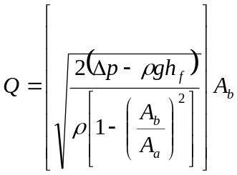
The change in pressure is found to be mostly as a result from the weight of the float.
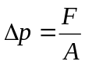
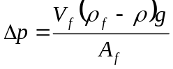
Where 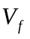is the volume of the float, 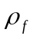 is the density of the float, and 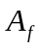 is the area of the float.

Ideal inviscid fluids would obey the flow equation found above, but the small amount of energy converted to heat most of the time lowers the actual velocity of the fluid. The viscosity of the fluid is accounted for through the use of the discharge coefficient (C).
